<!--This file created 2:29 PM 10/29/97 by Claris Home Page version 2.0-->1.4 Project
A Spherical Asteroid

You land your space ship on a spherical asteroid between Earth and Mars. Your copilot walks 1000 feet away along the smooth surface carrying a 10-ft rod and thereby vanishes over the horizon. When she places one end of the rod on the ground and holds it straight up and down, you — lying flat on the ground — can just barely see the tip of the rod, just on the visible horizon. You want to use this information to find the radius R of this asteroid (in miles).

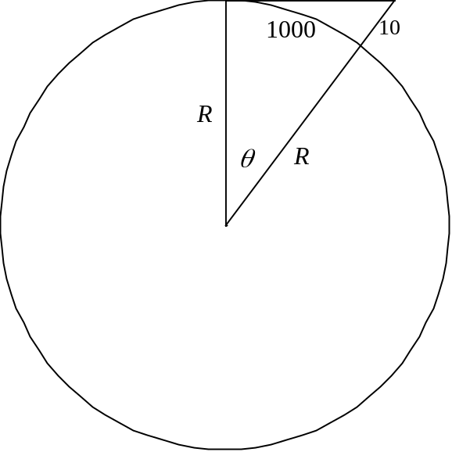

The fact that an arc of 1000 feet in a circle of radius R feet subtends a central angle of (radians) implies that
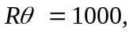 (1)

and you should be able to use the right triangle in the figure above to show that

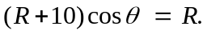 (2)

You can use the methods of Projects 1.2 and 1.3 to solve these equations graphically to approximate the radius R of the asteroid. Proceeding as in Project 1.2, for instance, you might solve each equation for R as a function of , obtaining

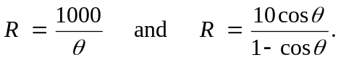 (3)

The figure below shows the graphs in the θR-plane of these two functions.

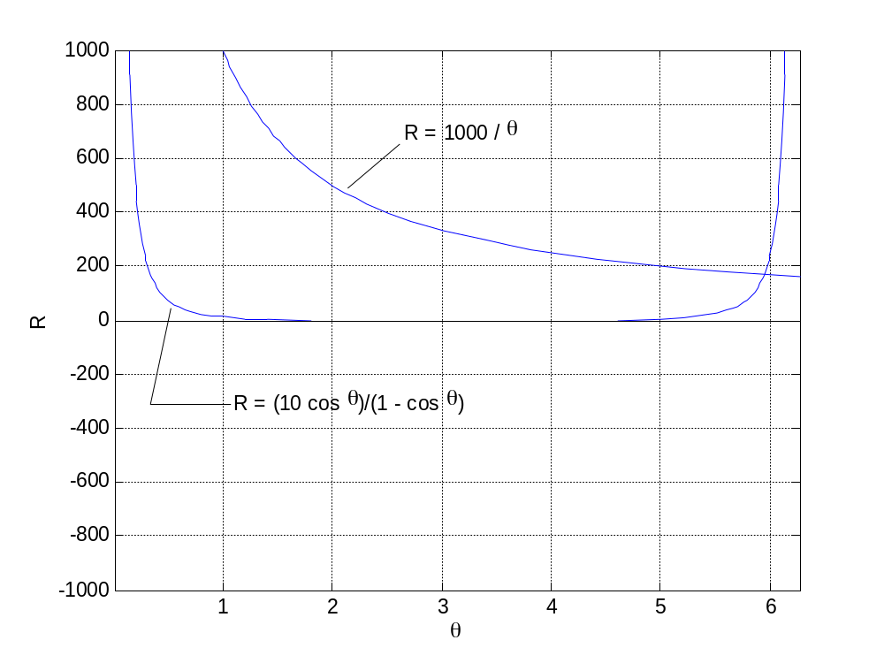

We appear to see only a single point of intersection, at a height of less than
R = 200 feet. Do you believe that our asteroid really has a radius less than 200 feet? What's wrong here?

An alternative approach (along the lines of Project 1.3) would be to eliminate R between Equations (1) and (2). Perhaps you can derive in this way the single equation

(4)

in  The graph of f is shown on the next page. Now we see lots of solutions, but the smallest nonzero value of again appears to be about 6 radians — almost a full revolution. This would mean that you're looking almost all the away around the asteroid at the tip of the rod behind you, which is absurd. Again, what's wrong here?

Suggestion: Think about the magnitudes of the variables R and . Certainly no one on earth vanishes over the horizon by walking merely a thousand feet. The asteroid must therefore be much smaller than the Earth. What does this imply about the size of R (and hence about the size of )?

When you've sorted this out, try it with an asteroid of your won. Let p be the largest digit and q the next largest digit in your student ID number. Suppose that your copilot's (very light) rod is p meters long and that she walks 100q meters away before all but the tip of the rod vanishes beneath the horizon from your view. Write the results of your investigation in the form of a carefully organized report. Tell precisely how you sorted out the correct answer — the radius of the asteroid — from among the various solutions of your equations.

